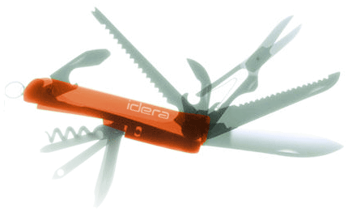

Specification

for

User Defined Counters

SQLdm Project Marfa

Vicky Sherrouse

11/15/2007



Proprietary and Confidential to BBS Technologies, Inc.

© 2006 BBS Technologies, Inc.; all rights reserved.

Revision history:
When? | Who? | What?
10/4/2007 | Vicky Sherrouse | Initial document
10/22/2007 | Vicky Sherrouse | Comments from prototyping session
10/24/2007 | Vicky Sherrouse | Identify required screenshots
10/31/2007 | Vicky Sherrouse | Final draft for review
11/15/2007 | Vicky Sherrouse | Final version

Table of Contents
1. Revision history: ii
2. Table of Contents iii
3. Requirements 1
3.1. Overview/Purpose 1
3.1.1. Related Customer Requests 1
3.2. Target Users 1
3.3. Feature/Function Market Requirements 2
3.3.1. Required Functions 2
3.3.2. Non-Supported Functions 3
4. Functional Design 3
4.1. User Interfaces 3
4.1.1. User-Defined Counter Configuration 3
4.1.2. Server Properties screen 14
4.1.3. Alert Configuration of Custom Counters 15
4.1.4. Custom Counters View 15
4.1.5. Add Servers Wizard 16
4.2. Installation and Upgrade 16
4.3. Permissions and other Required Configuration 16
4.4. Licensing Issues 16
4.5. Dependencies 16
5. Internal Design 17
5.1. Architecture 17
5.1.1. Snapshot Library 17
5.1.2. Collection Service 17
5.1.3. Management Service 18
5.1.4. Desktop Client 19
5.1.5. Repository 19
5.2. Installation Issues 20
5.3. Schedule 21
5.3.1. Work Breakdown and Sizings 21
5.3.2. Areas of Risk 21
6. Quality Assurance Considerations 22
6.1.1. Overview 22
6.1.2. Developer-Created Unit Tests 22
7. Documentation Considerations 22
8. Bibliography 22

Requirements

Overview/Purpose
The purpose of this feature is to allow users to add custom metrics to be collected by SQLdm for historical trending, on-demand monitoring, and scheduled refresh alerting. The ability to add custom counters serves a number of purposes, including the following:
- Allows monitoring of environment-specific counters, such as the size of a critical table or the length of a service broker queue. Most of these counters would never make sense to add to DM and would require an in-house solution to monitor.
- Allows users to add metrics which may be available in a competing product without intervention by the DM dev team. This allows a “checkbox feature” to be satisfied between releases and takes the dev team out of the metric war.
- Allows users to add metrics which may become available with a new service pack or operating system version as soon as it is deployed in their environment instead of going through the process of requesting a counter and waiting for the next release. This could be especially helpful for early adopters who may have a desire to use a feature far earlier than market saturation makes it worthwhile for the DM team to add monitoring.
Broadly speaking, this feature takes the DM dev team out of the critical path when a prospect raises a sales objection related to the availability of specific counters.

Related Customer Requests
- All customer requests for individual counters fall under this feature. Due to the amount of work currently required to add a counter – currently it requires changes to every component of the product - many of these requests are likely to be deferred indefinitely except where there is a true groundswell of interest.
- This feature received some attention at SQLPass this year, where prospects and customers brought up the possibility of monitoring Exchange and SQL Server Broker using their own custom batches and counters.

Target Users
There are two primary target users:
- An advanced DBA who has a very clear idea of the metrics they wish to track in their environment. They may be using an in-house solution to gather this information and may not be interested in purchasing a product which cannot give them exactly what they are used to seeing, or they may have a complex environment which requires the monitoring of obscure statistics.
- A more junior DBA who is working from a set list of metrics they have been told to track for their environment. These users may be looking for “checkbox features” and would be unwilling to consider a product that is missing a metric from their requirement list.
The most typical user will probably be an enterprise-level advanced DBA.

Feature/Function Market Requirements

Required Functions
The required functions of this feature, as described in the SQLdm User Defined Counters PRD, are as follows:
- Add custom metrics to SQLdm (the ‘system’)
  - User Scenario 1: Add counter to monitor
  - User Scenario 2: Apply (Add) a counter to a particular server
  - User Scenario 3: Modify user-defined counter
  - User Scenario 4: Delete configured counter from SQLdm system
  - User Scenario 5: Remove configured counter from monitored server
  - User Scenario 6: Apply user-defined counter to multiple servers
  - User Scenario 7: Verify availability and validity of user-defined counters on monitored server
  - User Scenario 8: View current user-defined counters inside DM
  - User Scenario 9: View current user-defined counters for a server
- Configure alerting on user-defined counters
  - User Scenario 1: Enable user-defined counter alert
  - User Scenario 2: Modify user-defined counter alert threshold
  - User Scenario 3: Modify previously configured user-defined counter alert thresholds
  - User Scenario 4: Configure user-defined alert notification
  - User Scenario 5: Disable user-defined counter alert
- Allow on-demand observation of user-defined counters
  - User Scenario 1: View graph of user-defined counters
  - User Scenario 2: View chart of user-defined counters
  - User Scenario 3: View error information related to user-defined counters
For the purposes of this specification, we are providing for users to add custom counters of each of the following types:
- OS Counters - OS Counters are defined as those counters which are gathered from WMI via OLE Automation in the fashion of DM’s current OS Metrics counters, analogous to PefMon. Examples of OS Counters currently in SQLdm 5.0 include Processor Queue Length and Average Disk Queue Length.
- SQL Counters - SQL Counters are those counters which are gathered via standard T-SQL from the server’s sysperfinfo system table, analogous to SQLdm 3.x. Examples of SQL Counters currently in SQLdm 5.0 include Lock requests/sec and Page reads/sec.
- Custom Batches – Custom Batches are scalar-valued T-SQL batches input by the user. These batches expose the ability to monitor variables which are not connected to system or SQL counters. These batches also allow user-defined monitoring of currently under-utilized SQL 2005 DMVs as well as metrics that may be very specific to the user’s environment, such as rowcount for a production table. Examples of T-SQL scalar-valued batch counters in SQLdm 5.0 include Max user connections and Database size.

The user defined counter configurations will be stored in the repository, along with the gathered statistics themselves.

Non-Supported Functions
- We will not provide custom reporting based on custom counters
- We will not provide documentation on available OS and SQL counters or their usage
- We will not support associating a custom counter with all servers as they are added to the system. Counters may be associated with a newly-added server or group of servers as part of the Add Server Wizard.
- We will not attempt to prevent SQL injection via the SQL Batch counter Open Issue – Should we therefore allow this particular counter type to be disabled?Ans: No
- We will not allow custom logic in the calculation of reference ranges for the Custom Counters on-demand view. This means we will not prevent percentage ratios from going over 100% and we will not allow “per second” calculations.
- We will not allow any counter value to be converted to its “per second” value if it is not already in that format – i.e. we will not do the division in the collection service
- We will not provide a means to import or export custom counter definitions, though the design does not preclude this from being added in the future if required.

Functional Design

User Interfaces

User-Defined Counter Configuration

Configure Custom Counters
The user-defined counter configuration screen will be made available in the Admin panel. All configured user defined counters will be listed in a grid view, along with their parameters and associated servers. Adding, modifying, testing, and deleting counters will be accomplished with context menu options as well as with explicit buttons. It will also be possible to assign multiple counters to multiple servers from this view. Multi-select will be allowed.
The following fields will be visible in the grid view for all counters:
- Category
- Type
- Name
- Description
- Count of associated servers
The following actions are available from this screen:
- View current counters
- Add counter to system
- View how many servers are using a specific counter
- Modify counter fields
- Delete counter from system
- Associate counter with monitored server(s)
- Remove counter from monitored server(s)
- Test configured counters
- Edit categories
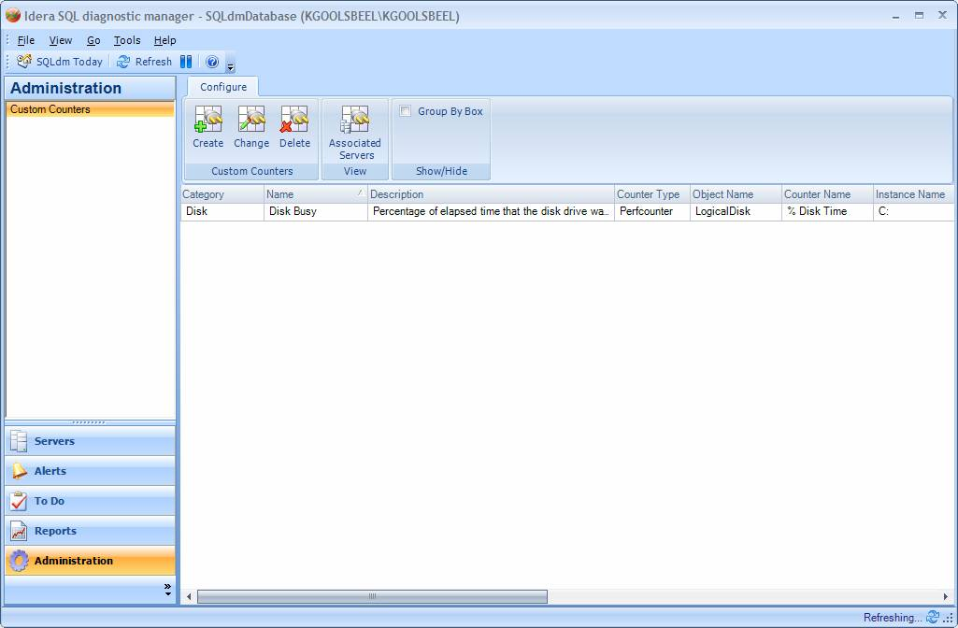

Add custom counter (wizard)
This wizard is reached by right-clicking in the counter grid or by clicking the Add button in the wizard. Adding a counter to SQLdm doesn’t apply it to a particular server, but it does make it available to apply to servers.
The required input parameters for all counters are as follows:
Counter Type | Name | Description | Data Type | Restrictions
All | Category | User-defined category name to help organize counters. | Text / Combo box | Text length of 100 characters (open for discussion – must work with Server Details view)
All | Display Name | User-defined display name that will be used to identify the counter in the User-Defined Counters and Alert Configuration screens. | Text | Must be unique across all counters (non-case-sensitive). Text length of 100 characters (open for discussion – must work with Alert Configuration view)
All | Description | User-defined description that will be displayed in alerts and the alert configuration screen | Text | Text length of 1024 characters (open for discussion – must work with Alert Configuration view)
All | Default warning threshold | Default value for the alert warning threshold – necessary for alerting. | Integer | Must be a whole number (per Kurt, alerting is based on integers). Fractional values should be converted to integers using the Scale parameter. Will be shown on the default alert configuration screen.
All | Default critical threshold | Default value for the alert critical threshold – necessary for alerting. | Integer | Must be a whole number (see default warning threshold). Default maximum position of alert configuration slider is based on a percent above this (this is already the behavior of the view). Will be shown on the default alert configuration screen.
All | Scale | Analogous to PerfMon – a value to multiply or divide the value by | Combo box | Drop-down will provide the same .0000001 – 10000000.0 scaling as in Perfmon and also allow direct entry. Default value of 1.0. Use this to convert a value to the nearest integer value for alerting purposes. Scale is currently used for a similar purpose in SQL mobile manager.
All | Calculation Type | Indicate whether to store a delta or an absolute value. | Radio button | Indicate whether to calculate a delta or not. A delta will probably be necessary for SQL Counters but probably not for most others. Probably need a more user-friendly name than “delta” for this. It is NOT possible for the service to know which way to treat a value without this input. If required, this would be the way to change a counter to a “per second” counter as well. This cannot be changed once set.
All | Alert Enabled by Default | Indicate whether to enable an alert by default when the counter is added to a monitored server | Checkbox | Will be shown on the default alert configuration screen.
All | Value Comparison | Indicate whether to use <= or >= as the comparison during alert processing | Drop-Down | An example of this in practice would be AvailableMemory, where a lower value is of higher criticality than a higher value
OS Counters | WMI Object Name | Full WMI object name | Text / Combo Box | Example “Win32_PerfFormattedData_  PerfOS_Processor” would be for processor data. Text length should be based on longest WMI object name, plus some buffer. This will be a combo box when a server is specified to pre-fill the list.
OS Counters | WMI Counter Name | Exact WMI counter name | Text / Combo Box | Example for processor used time would be PercentProcessorTime. Text length of 100 characters (open for discussion – check documentation on WMI). This will be a combo box when a server is specified to pre-fill the list.
OS Counters | WMI Instance Name | Exact instance name, or nothing | Text / Combo Box | Example “_Total” for all processors. Text length of 100 characters (open for discussion – check documentation on WMI). This will be a combo box when a server is specified to pre-fill the list.
SQL Counters | Object Name | Exact SQL object name, excluding server instance string | Text / Combo Box | For example, in sysperfinfo the object may be SQLServer:Buffer Manager so the user would enter “Buffer Manager”. Text length should be based field capacity from sysperfinfo. This will be a combo box when a server is specified to pre-fill the list.
SQL Counters | Counter Name | Exact SQL counter name | Text / Combo Box | Example “Stolen Pages”. Text length should be based field capacity from sysperfinfo. This will be a combo box when a server is specified to pre-fill the list.
SQL Counters | Instance Name | Exact SQL counter instance name | Text / Combo Box | Not to be confused with SQL Server instance name. Normally either blank, “_Total,” or a database name. Text length should be based field capacity from sysperfinfo. This will be a combo box when a server is specified to pre-fill the list.
SQL Statement | Batch to execute | Exact user-defined batch to execute | Text | Should yield exactly 1 numeric value. Text length open for discussion. We could limit to 4000 characters and suggest that longer batches be compiled as stored procedures on the monitored servers, or expand to ntext with an arbitrary limit. For context, our largest batch is 18KB, but our average batch is under 4K.

NOTE – Any of the above parameters which are too detailed to include in the UI at this point may nevertheless be made available for editing in the repository so that they may be included in the future. See 5.1.4: Repository for discussion of how these parameters would fit into the alert architecture.

Wizard Screen 1 – Counter Type
The user will be presented with the option to add an OS Counter, a SQL Counter, or a User-Defined SQL Counter. This may be satisfied with a radio button which adjusts the available fields according to the needs of each counter. When modifying a counter all of these fields will be pre-filled.
Optional – allow the user to specify the server from which to gather a list of OS or SQL Counters from this view.
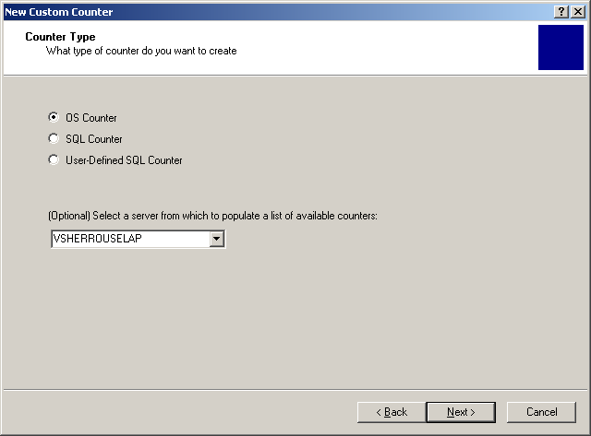

Wizard Screen 2 – Counter Identification
The user will be prompted to fill in the proper fields to identify the custom counter based upon the counter type. Note that we are not providing a mechanism to specify different parameters for different SQL Server or OS versions – any such constraints should be noted by the user in the Description field.
- OS Counter
  - WMI Object Name – Combo box may be pre-populated with a WMI query via the collection service. Direct entry is also allowed.
  - WMI Counter Name – Combo box may be pre-populated and filtered according to selection in Object Name. Direct entry is also allowed.
  - WMI Instance Name - Combo box may be pre-populated and filtered according to selection in Object Name and Counter Name. Direct entry is also allowed. Blank instance names should be shown as [blank].
  - Scaling factor
  - Calculation type
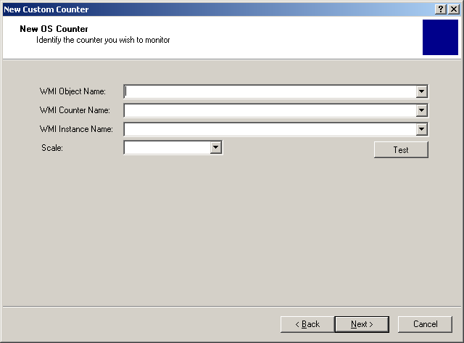
- SQL Counter
  - SQL Object Name – Combo box may be pre-populated with a SQL query from collection service. Direct entry is also allowed.
  - SQL Counter Name - Combo box may be pre-populated with a SQL query and filter according to the selection in Object Name. Direct entry is also allowed.
  - SQL Instance Name - Combo box may be pre-populated with a SQL query and filter according to the selection in Object Name and Counter Name. Direct entry is also allowed. Blank instance names should be shown as [blank].
  - Scaling factor
  - Calculation type
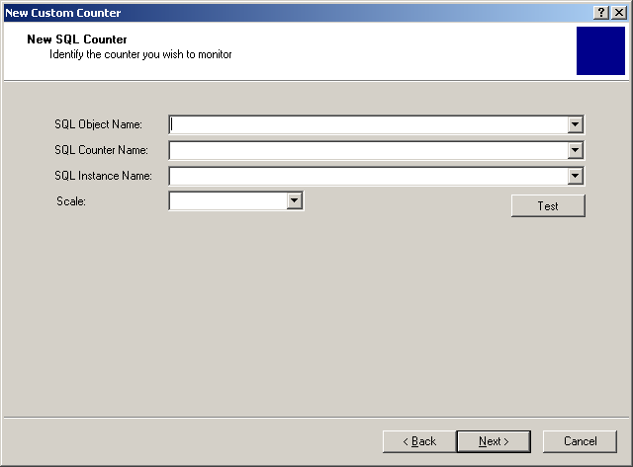
- SQL Batch
  - SQL Batch Definition – Direct entry only. Provides T-SQL color/formatting.
  - Scaling factor
  - Calculation type
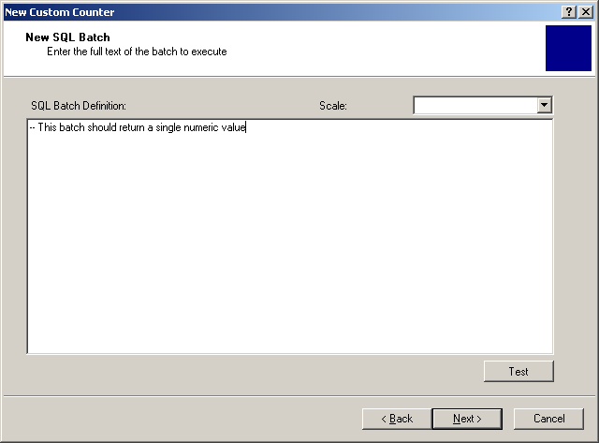

Once all required fields are input, the user may click “Test” to bring up the Test Custom Counter screen.

Wizard Screen 3 – Counter Name and Alert Defaults
The user will be prompted to provide the remaining metadata fields for the new counter:
- Category – Select existing or enter new
- Name – Must be unique
- Description
- Default warning threshold
- Default critical threshold
- Alert enabled by default
- Calculation Type
- Value Comparison (Open Issue)

After the completion of the wizard, the user should be asked whether to apply the new counter to monitored servers immediately. If they answer yes, the dialog from 4.1.1.3 will be displayed.
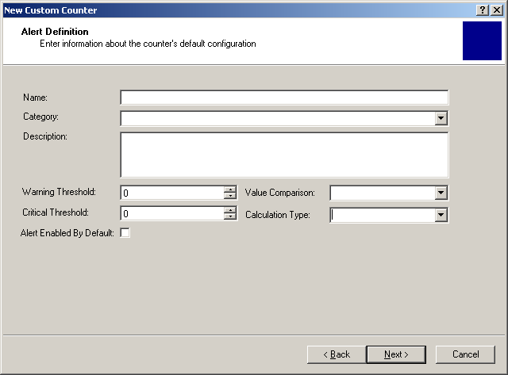

Apply custom counter to multiple monitored servers (dialog)
This dialog is reached by clicking on the Associated Servers button on the User Defined Counters screen. It may also be reached when adding a new counter and clicking “Yes” when prompted whether to apply the new counter to monitored SQL Servers.
A separate layout will be provided for single-counter view (shown) and multi-counter view (not shown). In the multi-counter view it will be possible to apply multiple counters to multiple servers.
Adding a counter to a monitored server will make it available for on-demand monitoring immediately and will begin collection for historical purposes immediately. Alerting behavior will be managed by the default alert configuration for the counter.
Removing a custom counter from a monitored server will prevent further collection but will not cause the data to be deleted (though the data will still be subject to the regular grooming schedule).
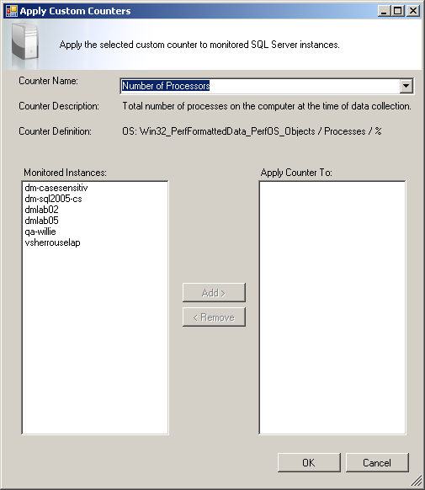

Modify custom counter (dialog)
Modifying a counter changes the definition in the system and for all servers which the counter has already been applied to. The modification dialog is accessed via the Custom Counters screen by selecting the counter and either clicking Modify on the ribbon or selecting Modify from the context menu. Upon clicking Modify, the user will be brought to a properties screen in the style of the Server Properties view, allowing modification of most elements of the counter. The metric type (OS, SQL, or Batch) and calculation type may not be.
Multi-select is not allowed – if multiple rows are selected, the Modify option in the ribbon should be greyed out.

Delete custom counter (dialog)
Deleting a custom counter from the entire system is accomplished from the Custom Counters screen by selecting the counter and either clicking Delete in the ribbon, pressing the Delete key, or navigating to Delete on the context menu. Upon deletion, a message will be displayed indicating that deleting a counter will make it unavailable to all servers, remove it from currently monitoring servers, and delete previously collected data from the repository. A list of servers which are currently using the counter should be displayed. The user should be given the option to cancel the delete and instead remove the counter from the target servers.
Multi-select is not allowed.

Test custom counter (dialog)
A user may test a previously-configured custom counter by selecting the counter and either clicking Test in the ribbon or selecting Test in the context menu. In case of success, the value of the counter is returned, and in case of failure, the error message should be displayed.
If multiple rows are selected in the custom counter view, the Test option in the ribbon should be greyed out.
Note from review: Need to add Scaling and Calculation Type to the grid below.8
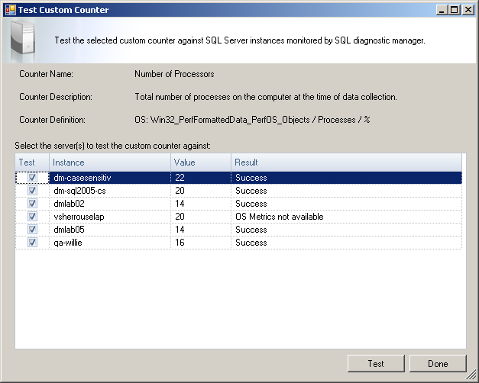

Server Properties screen
A user may add, remove, and test custom counters from a single-server perspective through a view on the Server Properties page.

Add/remove custom counter for a single monitored server (panel view)
This option allows counters to be added to and removed from a monitored SQL Server without having to select each counter. This view will be accessed through the Server Properties view and will be located on its own Custom Counters panel. Two list boxes will be shown, indicating active and available custom counters, with arrows to add or remove.
Adding a counter to a monitored server will make it available for on-demand monitoring immediately and will begin collection for historical purposes immediately. Removing a custom counter from a monitored server will prevent further collection but will not cause the data to be deleted (though the data will still be subject to the regular grooming schedule). Deletion of counters may only be done from the Custom Counters view.
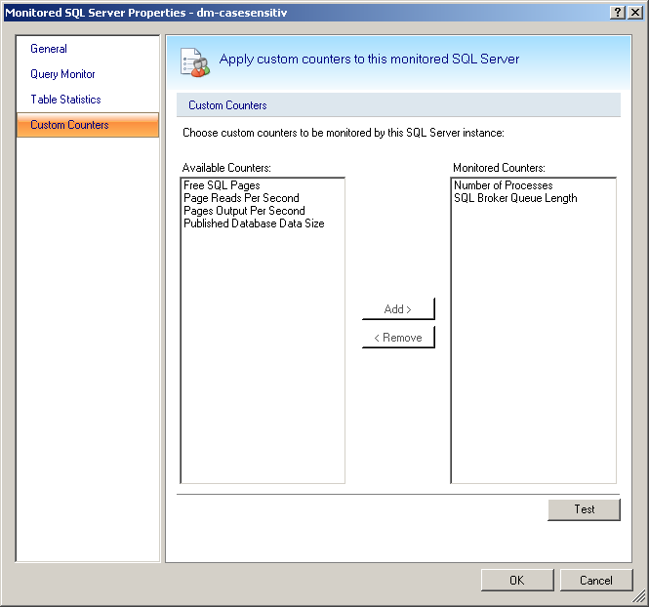

Test custom counters (dialog)
A user may test the configured custom counters by pressing the Test button, which will show an overview of configured counters, whether the probes succeeded, and the associated return value or return error message for each.

Alert Configuration of Custom Counters
The alert configuration view will show configured custom counters as available metrics for all standard alerting actions, including Enable, Disable, Modify Thresholds, and Notifications.

Default Alert Configuration
The Default Alert Configuration screen will display and allow modification to the alerting defaults for each counter as specified in the Add Counters wizard. All custom counters will be grouped together in the “Custom” group for display purposes.

Alert Configuration
Custom counters will be listed along with all other alerts in the Alert Configuration screen, under the group Custom Counters. An individual alert configuration for a given server will only be visible if that counter is being monitored by that server (open for discussion).
If a server was monitoring a custom counter, and then it is removed, if it is added back it will use the default alert configuration.

Custom Counters View

Server Tree View
A Custom Counters node will be added to the Server Tree. Any alerts for custom counters will be shown associated with this node. Clicking on the node will navigate to the Server Details view with the Custom Counters filter set.

Server Details View
All custom counters will be added to the Server Details view. They will be grouped by their custom category name with the prefix “Custom” – i.e. “Custom: Service Broker” – to allow for easy identification of custom counters. A filter option will be added to the view to allow display of custom counters only. When the view is reached via the Custom Counters node in the Server Tree this filter option will be set by default. This view may also be reached via click-through from the Alerts view.
Open Issue – If the Custom Counters filter is set do we still gather the Server Overview? Doing so allows us to back-fill the graph, but at a performance cost. Ans: Yes

Add Servers Wizard

Add custom counters to newly added server(s) (wizard screen)
If there are existing custom counters in the SQLdm system, the last step of the Add Servers Wizard will prompt the user to associate custom counters with the server(s) being added. This interface will be substantially identical to the add/remove custom counter panel on the Server Properties screen.

Installation and Upgrade
All components, including the repository, will require an upgrade. There are no special installation issues for this feature beyond a standard upgrade.

Permissions and other Required Configuration
Collection Service – No new permissions or configuration required
Management Service – No new permissions or configuration required
Desktop Client – To populate the WMI Counter drop-down, the desktop client user must have permissions to contact the target server using WMI from the client machine. This request will not go through the management or collection service. In case of failure the user may still directly input the counter names.
Repository – No new permissions or configuration required

Licensing Issues
There are no licensing issues related to this feature.

Dependencies
Custom OS Counters are dependant on the availability and functionality of OLE Automation and the WMI Service on the monitored server. These dependencies are the same as those for our existing OS Metrics.
Custom SQL Counters are dependant on the availability of SQL Counters in sysperfinfo. This dependency is the same as that for our existing server details.
Additional dependencies on OS version, SQL version, installed services, databases, and non-default SQL Server features are possible based on the particular counters selected by the user (i.e. Service Broker). The user will be responsible for keeping track of these dependencies for their own custom counters.

Internal Design

Architecture

Snapshot Library

Custom Counter Result Object
All custom counter values will be represented in a custom counter result object. This will allow all views to treat custom counters of different types in the same manner.
The custom counter result object will include the following properties in addition to the base Snapshot properties:
- Metric ID (for alerting)
- Display Name
- Category
- Counter Type
- Value (as double)
- Scaled value (as double)
- Scaling factor

Collection Service

Custom Counters Probe
Custom counters will be collected from a Custom Counters Probe, with a design similar to the existing Server Actions Probe. The probe will accept a configuration object with the parameters required to generate the batch. For OS and SQL probes these parameters will be inserted into a template SQL batch, while for custom batch probes only an identifying comments will be added at the beginning of the batch.
This probe will be used in both on-demand and scheduled collections. Each custom counter will require a server roundtrip via this probe in order to isolate errors that may occur in any individual custom counter.
Errors in this probe will not cause scheduled collection failure.
A copy of the custom counters available on the system will be cached on the collection service. This allows custom counter definitions to be sent to the collection service with the workload rather than being retrieved for every scheduled collection.
The probe configuration object will need to provide the following parameters at a minimum:
- Metric ID (for normal collection)
- Counter Type (provided for test or retrieved from cache for normal collection)
- Object Name (provided for test or retrieved from cache for normal collection)
- Counter Name (provided for test or retrieved from cache for normal collection)
- Instance Name (provided for test or retrieved from cache for normal collection)
- Batch (provided for test or retrieved from cache for normal collection)
- Server Startup Time (for delta calculation purposes)
- Previous Value (for delta calculation purposes)
The probe will return a fully-populated custom counter result object.

Custom Counter Alerting
All of the in-built alert definitions are currently stored as static objects available to the collection service alerting methods. As part of this feature, all in-built alert definitions will be moved to the repository so that custom counter alerts and built-in alerts will follow the same codepath.

SQL Counter Drop-Down Helper
A helper probe will be required to populate the SQL counters available on a target server. This will be modeled on the database list helper used throughout the desktop client. It will provide the following:
- All performance counter objects
- All counters filtered by object type
- All instances filtered by object and counter type

WMI Counter Drop-Down Helper
A helper probe will be required to populate the WMI counters available on a target server. This will perform a direct WMI request to a specified SQL Server using the user account which the collection service is running under. The probe will provide the following:
- All OS counter objects
- All counters filtered by object type
- All instances filtered by object and counter type

Management Service

Storing Custom Counters
Custom counters collected by the scheduled refresh will be written to the database along with all other regularly collected data. In case of failure, the error message should be written in lieu of the value itself.

Custom Counter Alert Notification
The alert notification process must be able to accept and process custom counter alerts in the same manner as built-in alerts. Custom counter alert notifications to the To Do List and the Error Log will use a standard message incorporating the custom counter name and value.

Desktop Client

Custom Counter UI Elements
The user interface elements required by this feature are described in greater detail in section 4 above.

WMI Counter Drop-Down Pre-Fill
The WMI Counter drop-down pre-fill for the Add Custom Counter wizard will require a direct WMI query from the desktop client to the monitored SQL Server. The list of available counters should be based upon the available PerfFormatted objects. The full names of the objects should be displayed in these drop-downs to prevent confusion, as any counter directly input by the user without the aid of the pre-fill will require the full name (for example, Win32_PerfFormattedData_PerfOS_Objects).

Repository

Tables
A number of new tables will be required to store custom counter definitions and results:
- CustomCounterDefinition – Used to store custom counter definitions. Denormalized.
  - MetricID – Foreign key to MetricInfo table, which holds name, category, and description
  - MetricType – Integer enumeration for OS, SQL, or Batch metric types
  - Object – OS or SQL Object. Null for Batch.
  - Counter – OS or SQL Counter. Null for Batch.
  - Instance – OS or SQL Instance. Null for Batch.
  - Batch – SQL text of batch to execute. Null for OS or SQL.
- CustomCounters – Used to store the scheduled refresh results of custom counter executions
  - SQLServerID – Foreign key to MonitoredSQLServers table.
  - UTCCollectionDateTime – Foreign key to ServerDetails table, indicating collection date/time.
  - MetricID – Foreign key to MetricInfo table, which holds name, category, and description
  - Value – Double value returned by counter, or null if error.
  - ErrorMessage – Text of any error that occurred during collection, or null if none.
- MetricMetaData – Representation of metric metadata for alerting purposes. The following fields are drawn from the MetricMetaData class in Idera.SQLdm.Common.Events and are subject to change. Because this is an internal-use table, certain of these fields may be serialized.
  - MetricID - Foreign key to MetricInfo table, which holds name, category, and description
  - LogEventID
  - ProcessNotifications
  - ValueType
  - MetricType
  - Configurable
  - MultiValued
  - MinValue
  - MaxValue
  - DefaultWarningValue
  - DefaultCriticalValue
  - Options
  - ResourceKeys
A small number of modifications may be made to existing tables. The only known modification is as follows:
- MetricInfo – Used to store name, category, and description of custom counters
  - Custom - Boolean field to differentiate custom counters from in-built counters

Procedures
The following new procedures will be required (subject to change):
- p_GetCustomCounters – Retrieve custom counter values for a given server, date, and time
- p_InsertCustomCounters – Save custom counter values to the database
- p_GetCustomCounterDefinitions – Retrieve custom counter definitions
- p_InsertCustomCounterDefinition – Save/update custom counter definition
- p_DeleteCustomCounterDefinition – Delete a custom counter from the system
- p_GetMetricMetaData – Retrieve alerting metadata for all alertable metrics
- p_InsertMetricMetaData – Save/update alerting metadata for any alertable metric
- p_DeleteMetricMetaData – Used to delete metric metadata during removal of a custom counter

Additionally, the grooming procedures will need to be updated to include the CustomCounters data table.

Installation Issues
All components, including the repository, will require an upgrade. There are no special installation issues for this feature beyond a standard upgrade.

Schedule

Work Breakdown and Sizings
Component | Who | Sizing
Repository Infrastructure – table structure, stored procedures for add/remove/modify/delete, grooming changes | Vicky & Kurt (50/50) | 5 days
UI - User-Defined Counter Configuration | Trent | 5 days
UI - Server Properties Screen | Trent | 3 days
UI - Alert Configuration of Custom Counters | Trent | 3 days
UI - Custom Counters View | Trent | 5 days
Common – Updates to snapshot library | Vicky | 3 days
CS - Custom OS metrics batch and replacement logic | Vicky | 2 days
CS - Custom SQL counter batch and replacement logic | Vicky | 2 days
CS - Custom SQL batch replacement logic | Vicky | 1 day
CS - Add and integrate user-defined counter probe | Vicky | 3 days
CS & MS – Updates to eventing logic for user-defined alerts | Kurt | 4 days
Total |  | 36 days

Areas of Risk
- The custom counter probes, while tested in prototype form, are new code and will have an associated learning code both in implementation and testing. This is already accounted for in sizing, but there remains a risk that could have an effect on the schedule.
- This specification has not been entirely integrated with the Historical Snapshots feature and there may be additional work required to support the infrastructure for that feature.
- This feature’s tight integration with alerts will be affected by the new Alert Based on Past Performance feature, which may lead to increased complexity during implementation.
- The alert work in this feature will affect the overall bubbling up of alerts in the UI and must be handled very carefully.
- The behavior of OS counters on SQL Server clusters is not well understood and could lead to issues during testing.

Quality Assurance Considerations

Overview
- The OS counters exposed in this feature will require testing on a matrix of SQL Server and Windows versions to a greater degree than was previously required by SQLdm.
- Behavior of OS counters on SQL Server clusters is not well understood and particular attention should be paid to this during test plan creation.
- The changes to the alerting infrastructure will require a general pass through all alert configurations, not just those related to custom counters. The behavior of the custom alerts in the tree-view should be given attention as well.
- It should be understood that inherently or intentionally dangerous or destructive T-SQL that is entered as a custom T-SQL batch will be executed as entered and this may have a negative impact on the monitored server. This is considered an advanced feature and thus any entered SQL which would have an equally damaging effect whether or not it was executed by SQLdm should be considered user error – i.e., a SHUTDOWN command will cause the server to shut down, but this is not a bug in SQLdm.

Developer-Created Unit Tests
None identified.

Documentation Considerations
- It may be appropriate to document where/how the user may find a list of OS counters (TechNet, for instance).
- It should be made clear that we will not be scrubbing custom SQL batches for SQL Injection protection.
- Instructions on how to re-install missing SQL Server counters and how to troubleshoot WMI permission problems for OS counters are available from the technical support knowledge base. These should probably be added to the help file.

Bibliography

